Incident Lifecycle Automation in ServiceNow
Project Documentation format
1. Introduction
• Project Title: Incident Lifecycle Automation in ServiceNow
• Team Members: List team members and their roles.
2. Project Overview
• Purpose: Automate and standardize the Incident Management lifecycle using ServiceNow’s Incident module.
• Features: Incident creation and classification; Knowledge Management integration; reassignment to appropriate support groups; Level 2 investigation and resolution; emergency change requests from incidents; child incident creation for recurring issues; knowledge article generation from resolved incidents; improved SLA compliance and service visibility.
3. Architecture
• Platform: ServiceNow Incident Management module.
• Incident Lifecycle: Incidents are created and classified by Service Desk agents, routed to appropriate support groups, investigated and resolved by Level 2 technicians, and connected to related changes or child incidents when required.
• Knowledge and Change Integration: Knowledge Management supports faster resolution and resolved incidents can contribute to knowledge articles. Emergency change requests can be created directly from incidents.
4. Setup Instructions
• Prerequisites: Access to a ServiceNow instance with the required Incident Management, Knowledge Management, and Change Management capabilities.
• Configuration: Configure incident classification, assignment groups, lifecycle states, SLA rules, knowledge integration, emergency change creation, child incident handling, and resolution-to-knowledge processes.
5. Folder Structure
• ServiceNow Application Areas: Incident Management, Knowledge Management, Change Management, Assignment Groups, SLA Management, and related configuration.
6. Running the Application
• Access the ServiceNow instance and open the Incident module. Service Desk agents create and classify incidents; support groups receive assigned incidents; Level 2 technicians investigate and resolve them; related change requests and child incidents are created when required.
7. API Documentation
• Not specified in the supplied project content. If integrations or APIs are implemented, document the exposed endpoints, request methods, parameters, and example responses here.

8. Authentication
• Authentication and authorization are handled through ServiceNow user access and role-based permissions. The supplied project description does not specify particular authentication tokens or session mechanisms.
9. User Interface
• Provide screenshots of the ServiceNow Incident workspace, incident creation and classification, assignment to support groups, Level 2 investigation, SLA information, related changes, child incidents, and knowledge article generation.
10. Testing
• Test incident creation and classification, assignment and reassignment, Level 2 investigation and resolution, SLA behavior, emergency change creation, child incident creation, and generation of knowledge articles from resolved incidents.
11. Screenshots or Demo
• Provide screenshots or a link to a ServiceNow demonstration showing the complete incident lifecycle from creation through resolution, including related knowledge, change, child-incident, and SLA views.
12. Known Issues
• Any known configuration gaps, SLA exceptions, assignment issues, integration limitations, or workflow defects should be documented here. No specific known issues are provided in the supplied project content.
13. Future Enhancements
• Potential enhancements include broader automation of incident routing and escalation, richer SLA and service-visibility dashboards, improved recurring-incident correlation, and expanded knowledge reuse from resolved incidents.

ServiceNow Project Screenshots
Screenshots extracted from the supplied ServiceNow project images PDF

ServiceNow Project Screenshot – 1
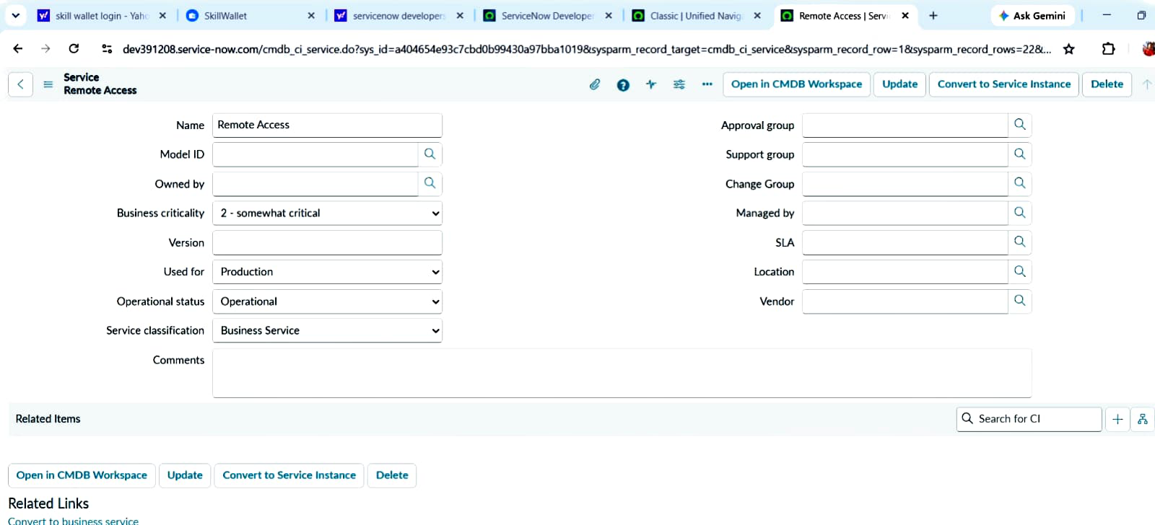

ServiceNow Project Screenshot – 2
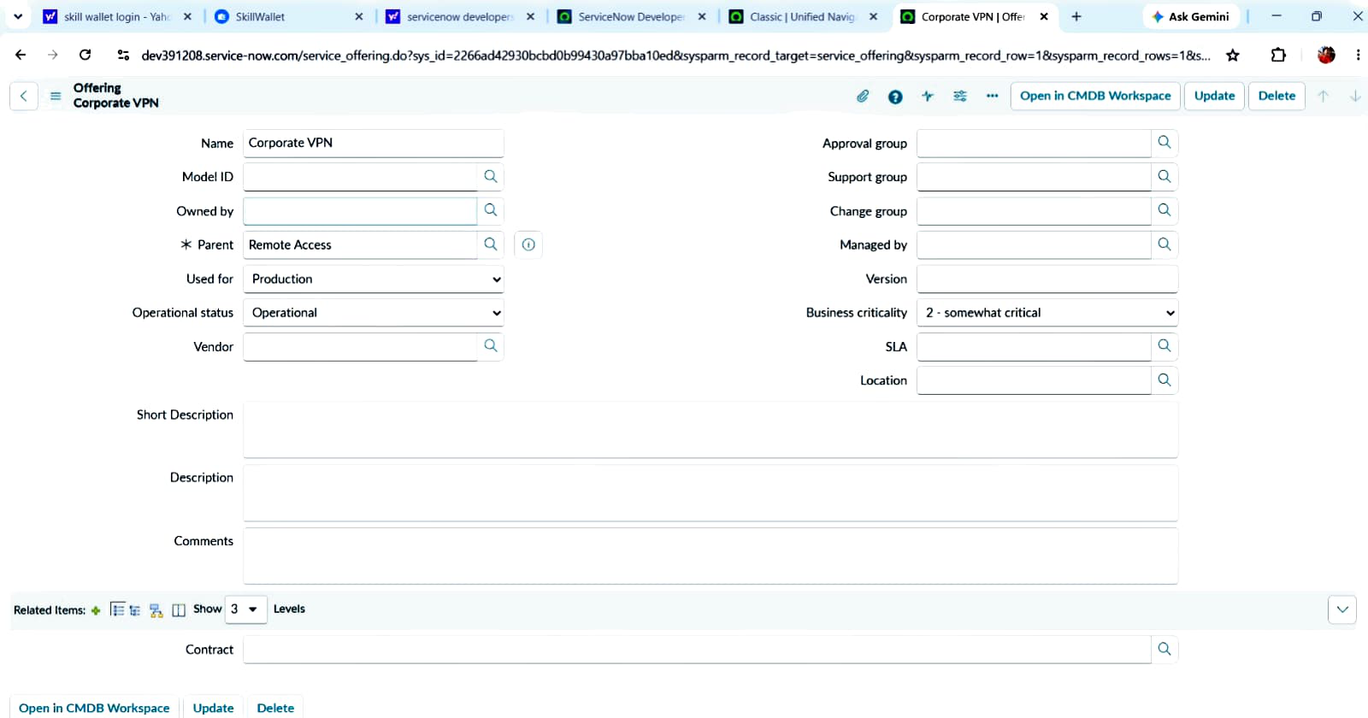

ServiceNow Project Screenshot – 3
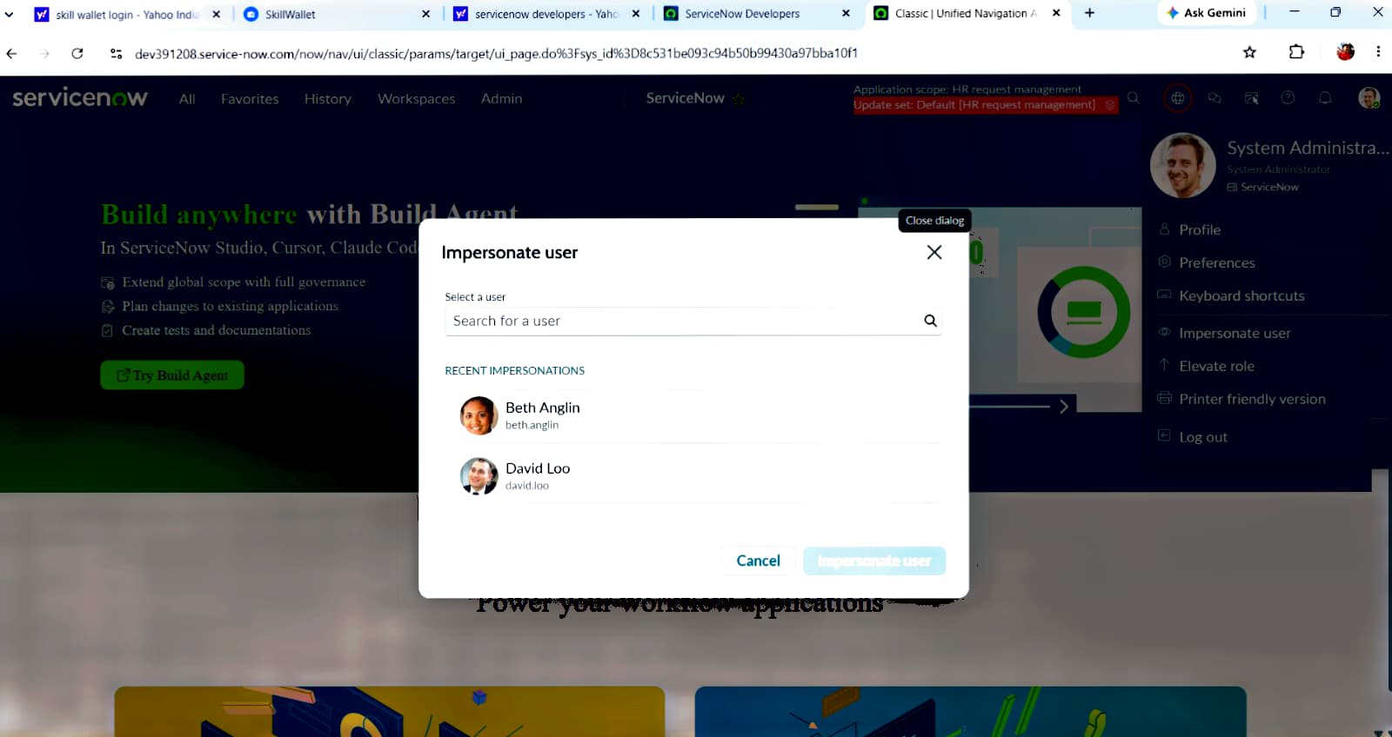

ServiceNow Project Screenshot – 4
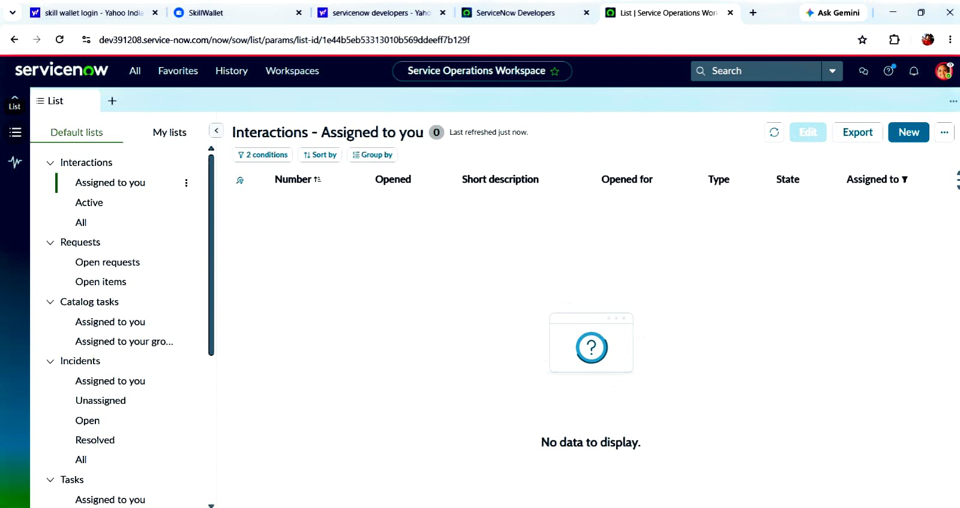

ServiceNow Project Screenshot – 5
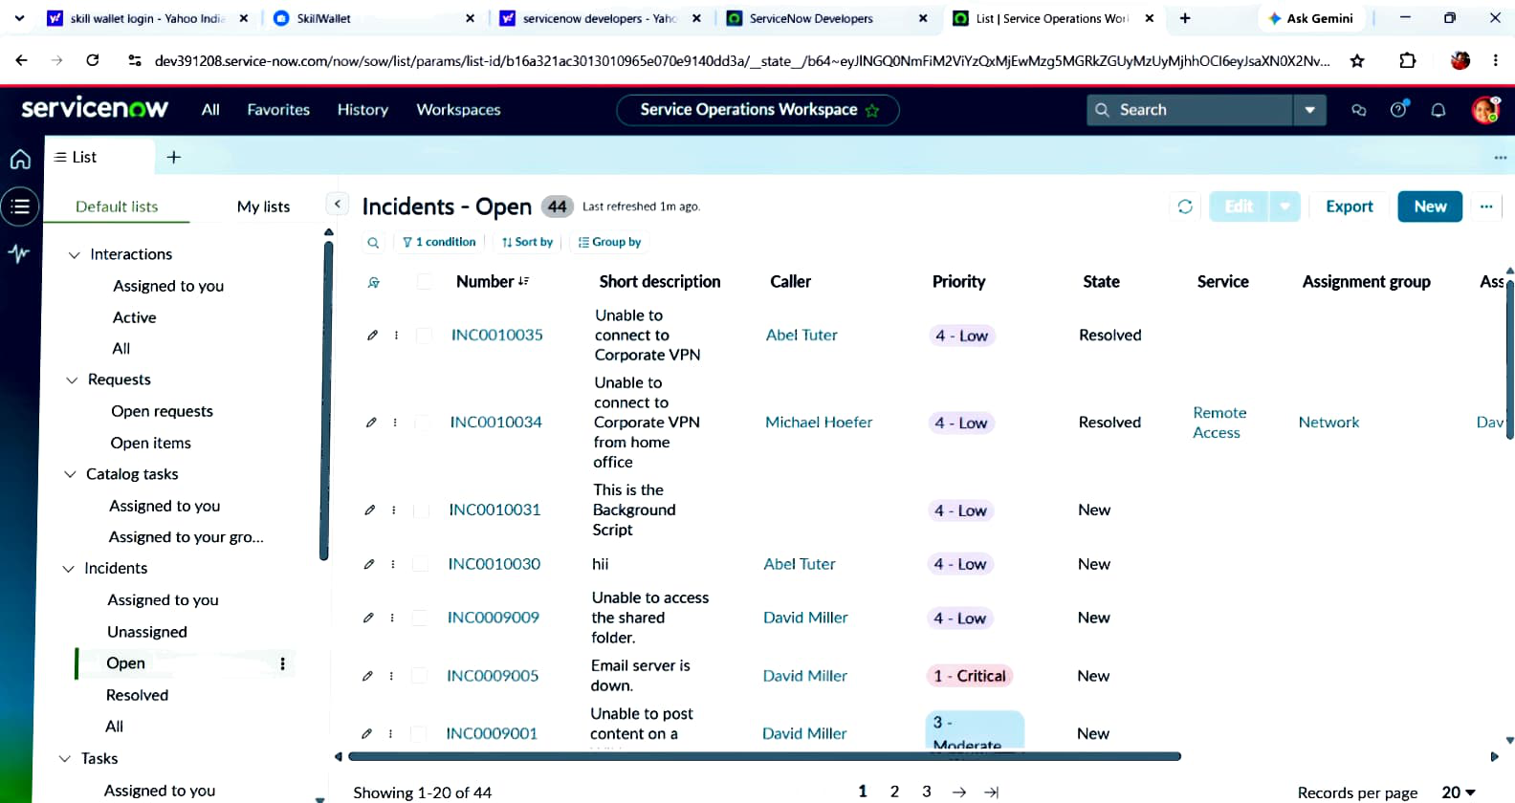

ServiceNow Project Screenshot – 6
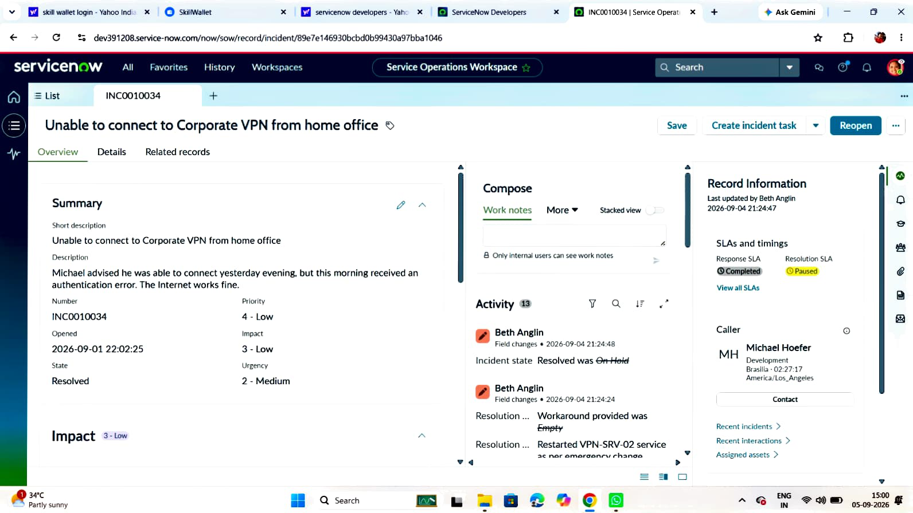

ServiceNow Project Screenshot – 7
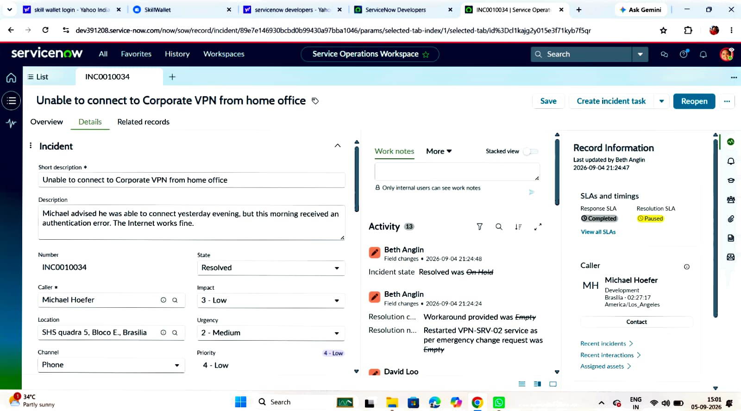

ServiceNow Project Screenshot – 8
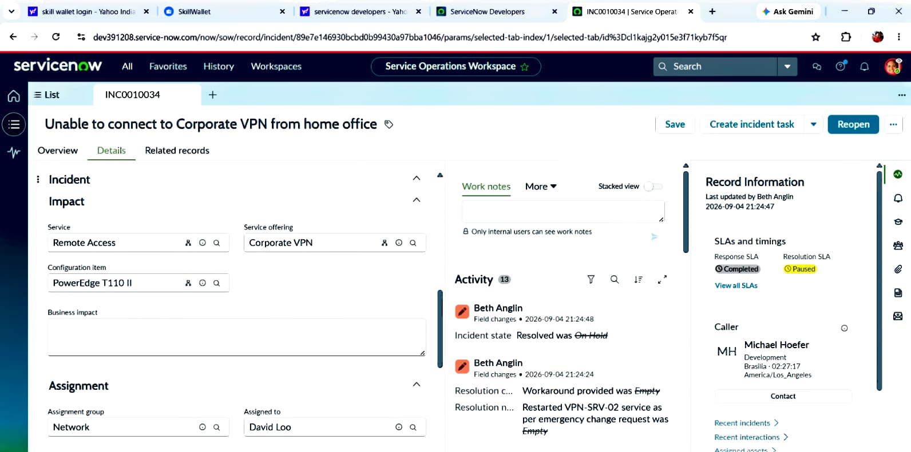

ServiceNow Project Screenshot – 9
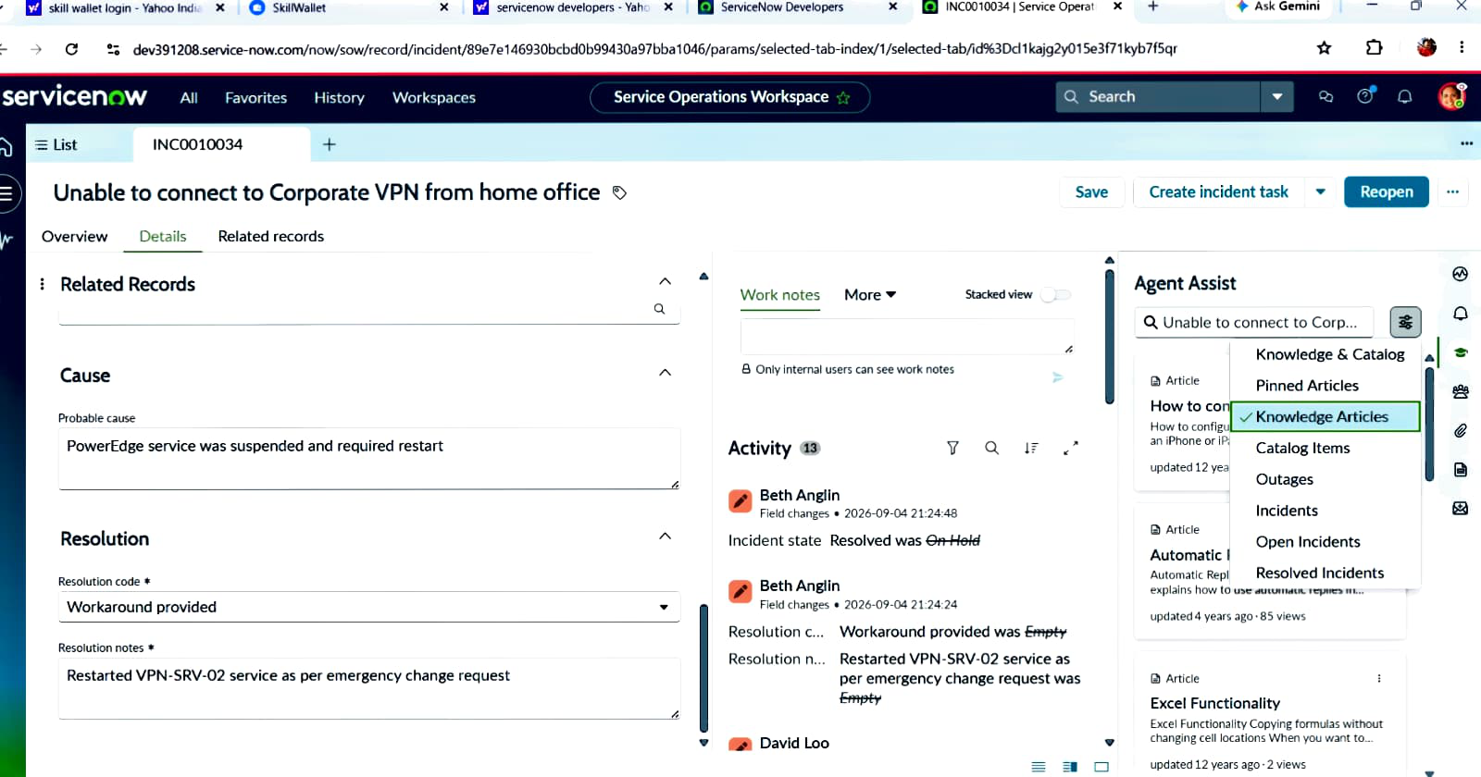

ServiceNow Project Screenshot – 10
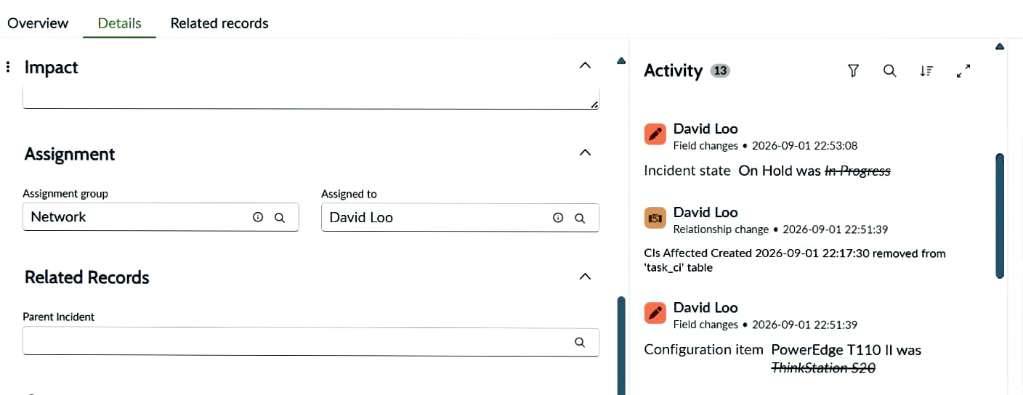

ServiceNow Project Screenshot – 11
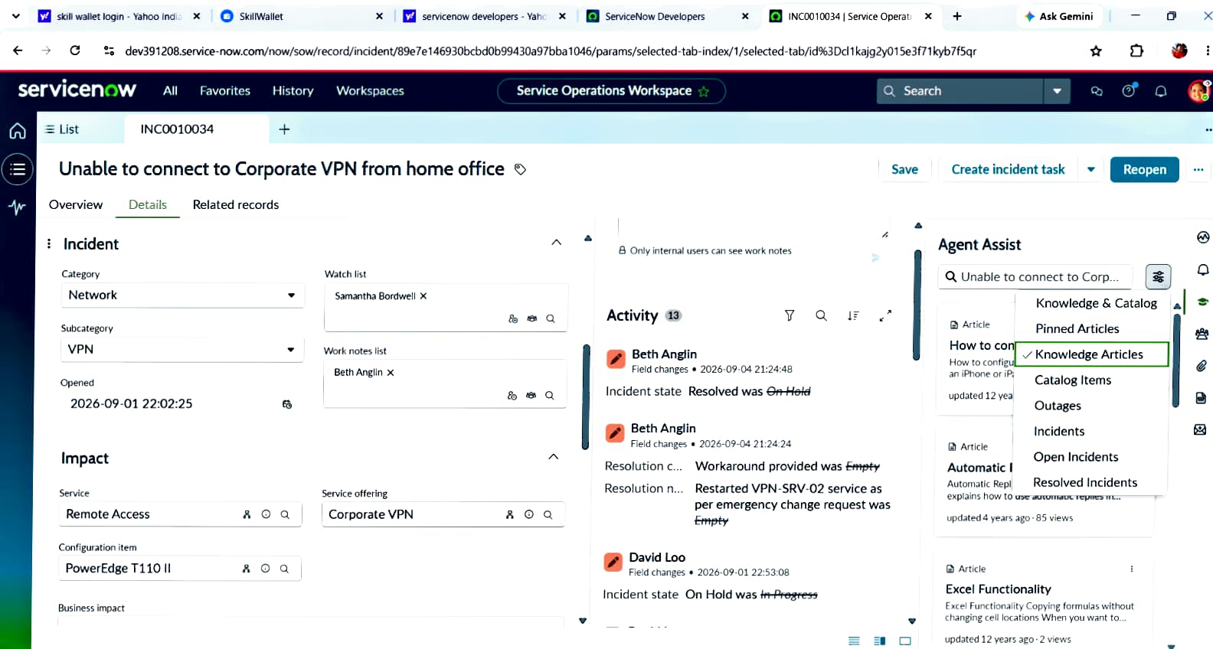

ServiceNow Project Screenshot – 12
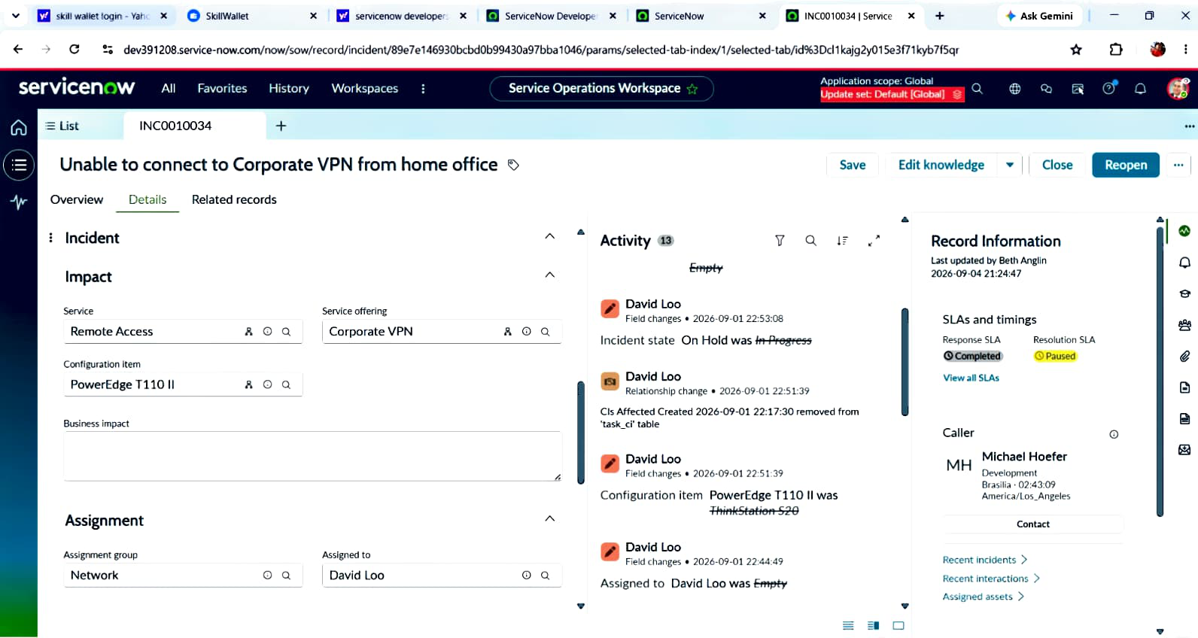

ServiceNow Project Screenshot – 13
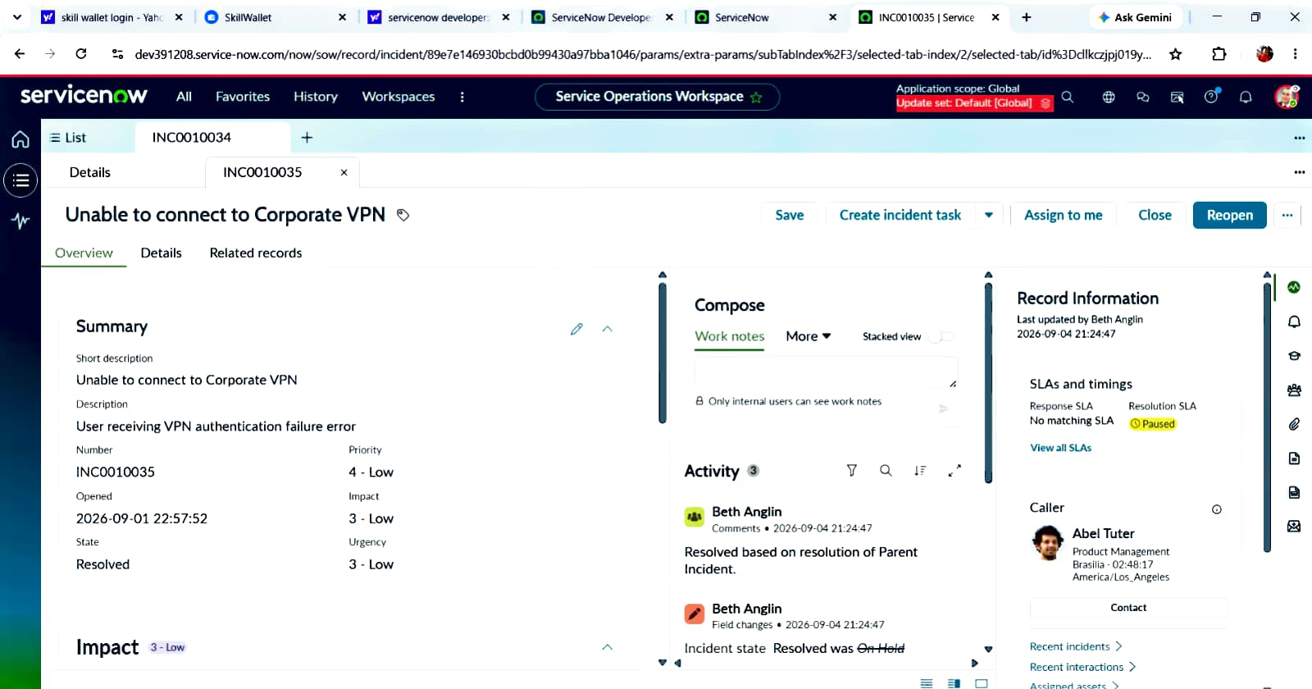

ServiceNow Project Screenshot – 14
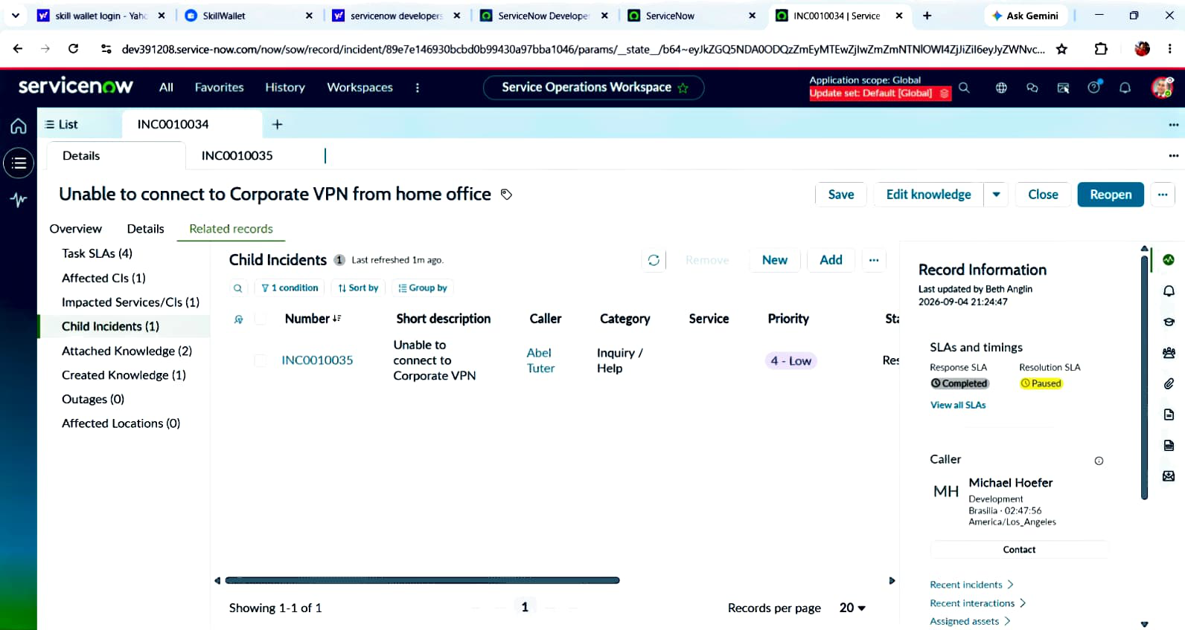

ServiceNow Project Screenshot – 15
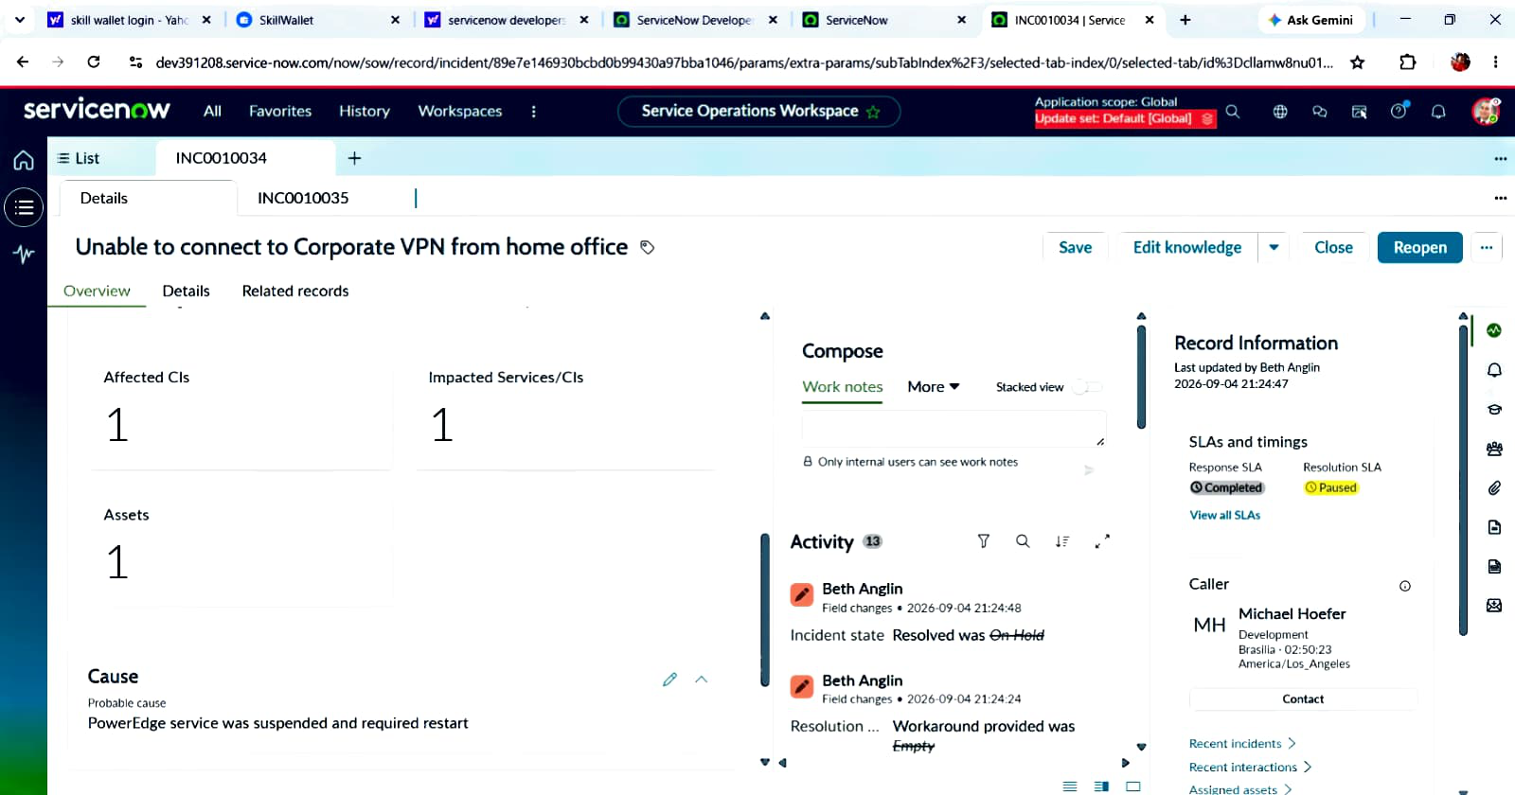

ServiceNow Project Screenshot – 16
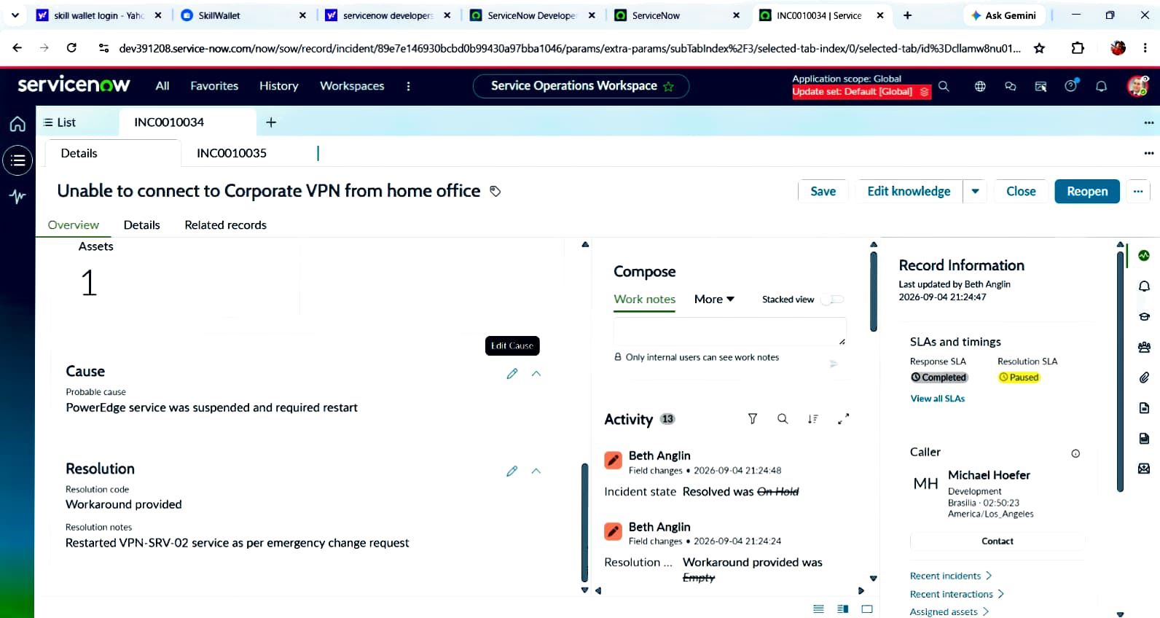

ServiceNow Project Screenshot – 17
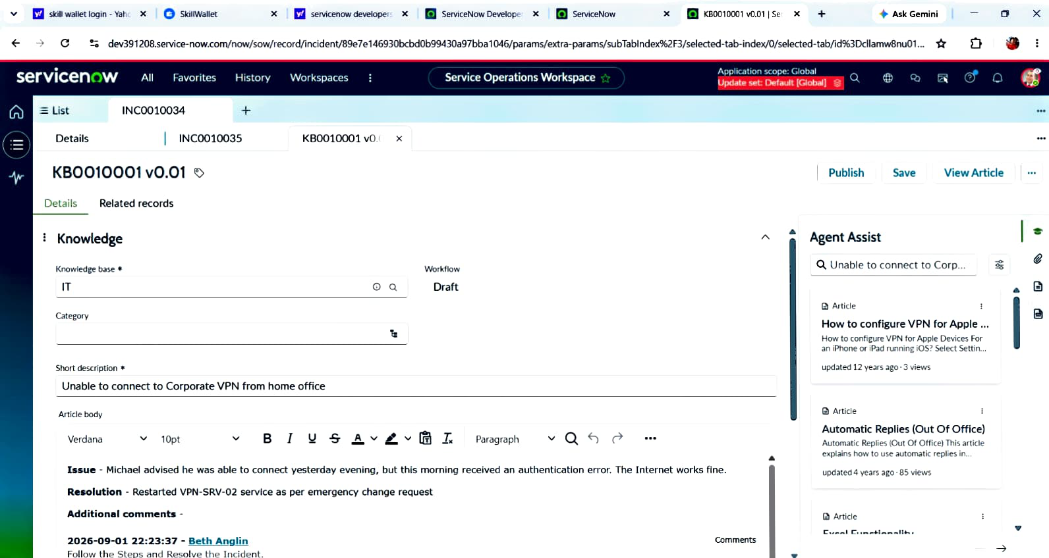

ServiceNow Project Screenshot – 18
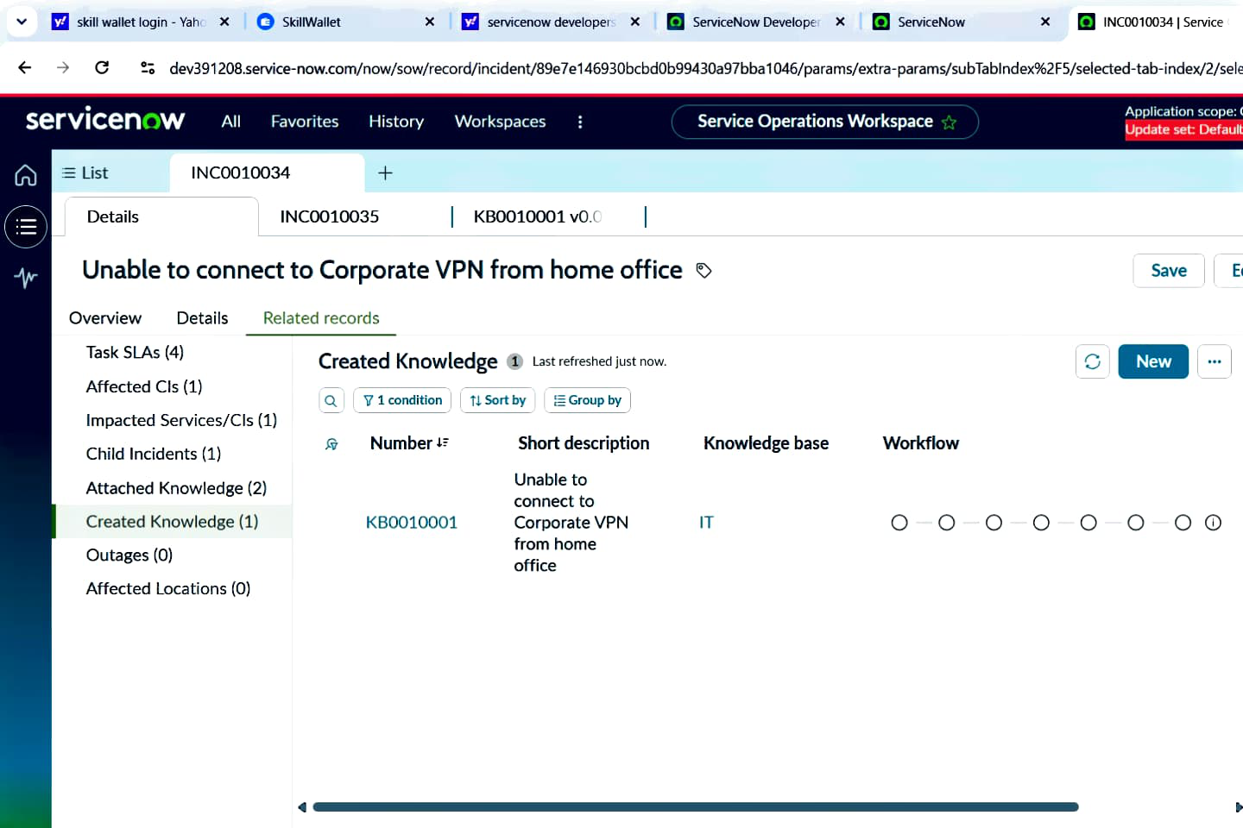

ServiceNow Project Screenshot – 19
